Saint Patrick’s Day

Cílem této hodiny je představit studentům původ svátku sv. Patrika a dát do kontextu oslavy, jak je známe dnes. Na konci hodiny budou žáci vědět, kdo je sv. Patrik, dokáží popsat základní body jeho života a budou si vědomi významu tohoto svátku pro Iry. Pracovní list je vhodný pro žáky SŠ, lze využít i na ZŠ (úroveň A2–B1).

Žáci pro tyto aktivity potřebují přístup k internetu a psací potřeby.
Svatý Patrik
________________________________________________________
- Učitel píše na tabuli slova, postupně vytváří myšlenkovou mapu s volným středem. Studenti hádají téma hodiny. Ve chvíli, kdy uhodnou, je střed doplněn, a myšlenkovou mapu dokončují žáci. Na tabuli doplňujeme i chybné prekoncepty a česká slova, neznají-li žáci termín. Na konci hodiny budou chyby opraveny.
Slova v pořadí, jak je zapisujeme:
ISLAND, GOD, FIFTH, MAN, EUROPE, CHRISTIAN, MARCH, GREEN, SAINT, IRELAND
- Studenty rozdělíme do skupin po 3–4 a požádáme je, aby si vybrali svého „leadera“. Ten má za úkol organizovat práci ve skupině, shromažďovat informace, které společně získají, a doplnit je do profilu sv. Patrika (str. 5). Následně jim rozdáme pracovní listy. Ty by měly být ideálně rozstříhané na jednotlivá cvičení, aby si mohli dle libosti ve skupině rozdělit práci. Vypracování úkolů by studentům mělo zabrat přibližně 30 minut.
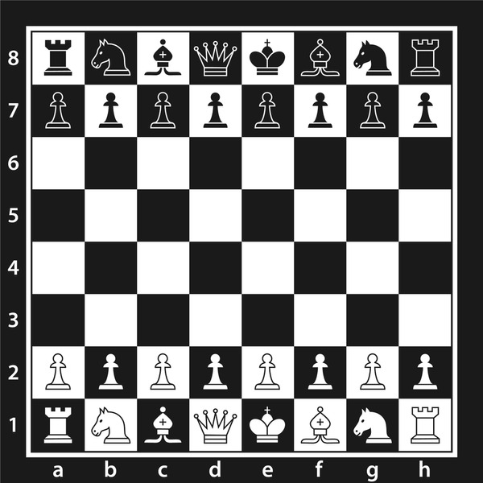
- How are the chess pieces called? Look it up to find the job of Saint Patrick.
1A ROOK 1B KNIGHT 1C BISHOP
1D QUEEN 1E KING 2A PAWN

Which one is the job? Solve the riddle.
In musical notes, I am a key,
Not in the river, but in cup of tea,
I come in cookies, not in pie,
In the heart of clock, where time does fly,
Written in ocean, heard in sea,
Do you dare to guess, what might I be?

ANSWER: ………C………
H | D | N | A | L | E | R | I | C
D | E | W | A | M | S | Y | S | H
U | K | C | A | A | A | P | T | U
B | U | C | I | D | R | R | E | R
L | D | N | I | G | A | N | C | C
I | T | L | D | R | R | B | E | H
N | O | C | A | M | T | E | E | A
H | S | L | A | V | E | A | E | .
B | R | I | T | A | I | N | P | N
2. Translate following words and look them up in the puzzle. The remaining letters will tell you what happened to Saint Patrick when he was 16.
BRITÁNIE (BRITAIN), DUBLIN (DUBLIN),
IRSKO (IRELAND), SVATÝ (SAINT),
ZELENÁ (GREEN), BŘEZEN (MARCH),
CÍRKEV (CHURCH), SVÁTEK (HOLIDAY),
PATRIK (PATRICK)
Answer:
He was captured and became a slave.

3. What do the following events have in common? Can you add more events which would fit in?
- The Kingdom of Italy is proclaimed.
- Commodus becomes the emperor of the Roman Empire.
- The Treaty of Brussels is signed.
- Golda Meir becomes the first female Prime Minister of Israel.
- A referendum to end apartheid in South Africa is passed.
- ……………………………………………………………………………….
- ……………………………………………………………………………….

Answer: …………everything happened on March 17………………………………………….
4. Can you solve the cryptogram? If you can do it, you will learn about Patrick’s birthplace.
Postup řešení: V nápovědě odpovídají slova číselnému přepisu, jsou však promíchaná. Studenti musí nejprve přiřadit slova k číselným skupinám, tím zjistí, jaké číslo odpovídá jakému písmenu. Následně písmena doplní do kryptogramu a vyluští odpověď.
Answer: Saint Patrick was possibly born at the end of the fourth century in Glannoventa, which is in today’s England, specifically the village of Ravenglass.
5. Look up the difference between shamrock and clover.
Answer: shamrock can only have three leaves while clover can have a fourth leaf
- In exercise 2 you learned about one important part of Saint Patrick’s life. Find your way through the maze to find out how long did it last. (answer: 6 years)
- Connect following Saint Patrick’s Day traditions to their descriptions.
4) KISS ME, I’M IRISH
Irish legend says, that kissing the famous Stone in Blarney Castle gives the person the gift of charming speech. Not many have the chance to do it, so Irish decided to transfer the charm to everything Irish and often wear buttons or shirts with the phrase on Saint Patrick’s Day.

2) DROWNING SHAMROCKS
People wear shamrocks, a symbol of good luck in Irish culture, on this day. At the end of the day, they may place the shamrock in their drink, often a glass of whiskey. It's a way to honor Saint Patrick and the festivities, adding a bit of fun to the celebration. It's important to note that it's more of a symbolic gesture than a serious tradition, and it adds a touch of Irish charm to the Saint Patrick's Day celebrations.

1) WEARING GREEN
People dress in various shades of the colour, including clothing, accessories, and even temporary green accessories like hats or beads. This tradition is rooted in Irish culture and the belief that green brings good luck. It's a festive way to join the celebrations and show solidarity with Irish traditions.

3) LOOKING FOR LEPRECHAUNS
They are little, magical creatures from Irish stories who hide pots of gold. People sometimes playfully pretend to search for them during the celebrations. It's all in good spirits, and it adds a playful touch to the day. Even though the creatures are make-believe, looking for them can be a fun way to enjoy the imagination and joy of Saint Patrick's Day.

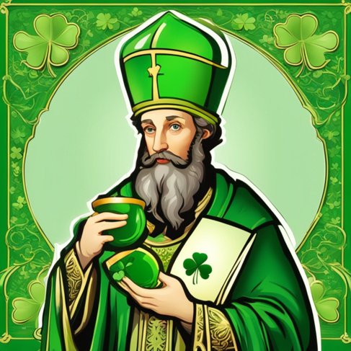
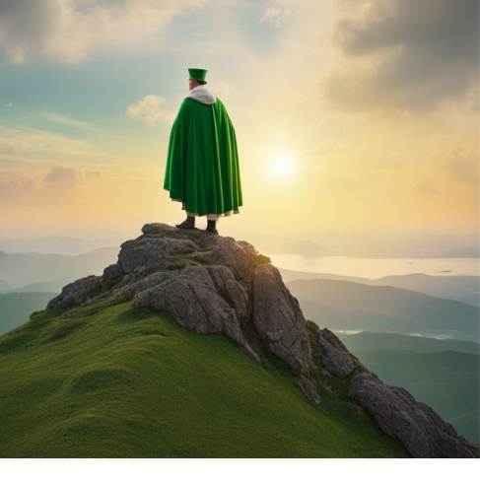
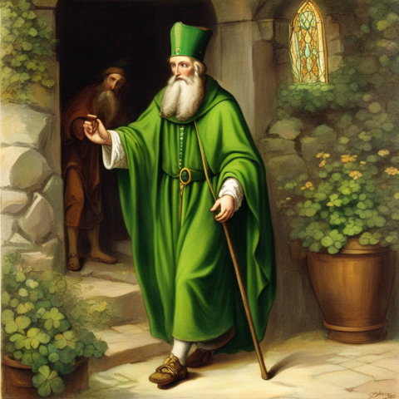
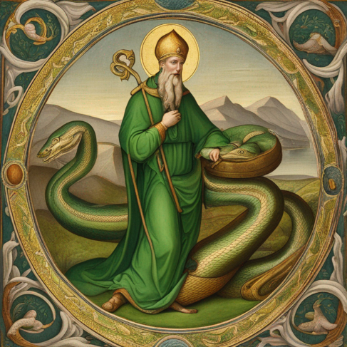
- Connect the legends to the pictures. (obrázky byly vytvořeny v aplikaci Canva s využitím AI)
(top right) Saint Patrick, Ireland's saint, is famous for a story. Some say he sent all the snakes away. There were probably no snakes in Ireland, but the tale means he removed bad things, like old beliefs. People think Patrick got rid of wrong, pagan, ideas.
(top left) Patrick used a green shamrock with three leaves. He wanted to show the Holy Trinity – Father, Son, and Holy Spirit – like a special team. The shamrock is now a symbol of Patrick and Ireland. People like its green color.
(bottom right) Saint Patrick scolded an innkeeper for pouring him half-empty glass of whiskey. He said a demon is growing in her cellar to také her to the hell, because she was not honest. When he came back, he saw a big change. The innkeeper gave generous cups of whiskey to guests. They both went to the cellar and saw the naughty creature getting smaller. Patrick said that people should have a whiskey on the special day as a thank you for being kind.
(bottom left) Saint Patrick went up a mountain named Croagh Patrick. He didn't eat for 40 days and nights at the top. It is similar to the story of Moses, who went up Mount Sinai. People still climb Croagh Patrick today to remember Saint Patrick.

- Skupiny vyšlou své leadery k tabuli, kde je jejich úkolem opravit a doplnit myšlenkovou mapu. Poté je možné přehrát video a doplnit jakékoli chybějící informace. Následně probíhá společná diskuze, kde studenti shrnou, co nového se dozvěděli. Po hodině jim můžeme ve třídě vyvěsit vyplněné profily (následující strana) sv. Patrika.

Fill in the profile of Saint Patrick
Picture
Date and place of birth: 4th century, Glannoventa
Date of death: March 17th
When he was 16 he was captured and became a slave.
After 6 years he escaped and became
a bishop and missionary in Ireland. He is
credited with bringing Christianity to England.
He used the symbol of shamrock to explain Holy
Trinity to the pegan (pohanský) people of Ireland.
There are many stories about his acts. Similarly to Moses, he spent 40 deys feasing on a mountain.
Another story is about a dishonest innkeeper who poured him half empty glass of whiskey. He said a demon is waiting for her in a cellar. She became a better person and the demon disappeared.
He removed snakes from Ireland. Not literally, it probably means that he got
rid of bad things and old beliefs (paganism).

Saint Patrick’s Day
Saint Patrick’s Day is celebrated on March 17th around the world. On this day people often wear green colour and pin shamrocks to their coats and hats. Some can also wear shirts and buttons with „Kiss me, I am Irish“ written on. Some funny traditions include looking for leprechauns and drowning shamrocks.

Autor: Šárka Hanetšlegerová
Toto dílo je licencováno pod licencí Creative Commons [CC BY-NC 4.0]. Licenční podmínky navštivte na adrese [https://creativecommons.org/choose/?lang=cs].

