Reading: Multiple Choice

Přečtěte si pět krátkých textů. Na základě informací v textech vyberte k úlohám 1-5 vždy jednu správnou odpověď A-D.

________________________________________________________

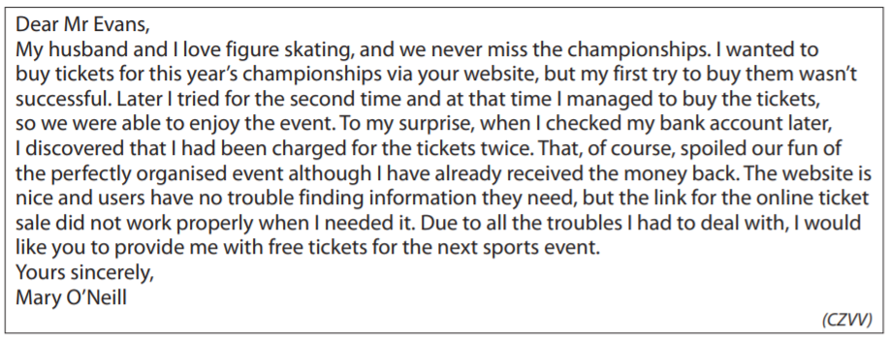
- What does Mary O’Neill want Mr Evans to do?
She wants him to:
- improve the design of the website.
- give her tickets free of charge.
- organise sports events better.
- give her the money back.

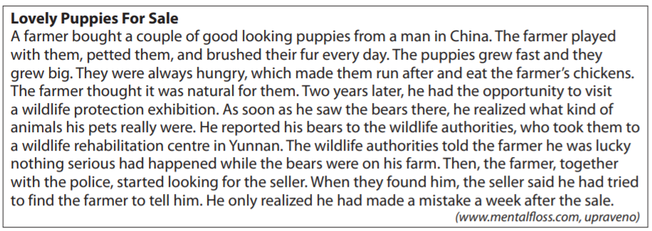
- When did the farmer find out the truth about his pets?
He found out the truth about his pets:
- when the wildlife authorities told him.
- when they started killing his chickens.
- when he saw an exhibition of protected animals.
- When he contacted the man who had sold the pets to him.

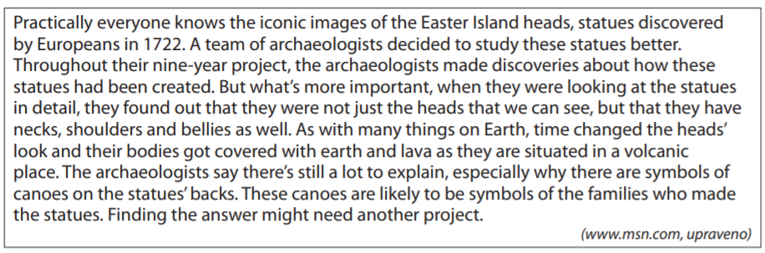
- What is the best headline for this piece of news?
- Parts of an Old Boat Discovered on Easter Island
- New Statues of Heads Discovered on Easter Island
- The Famous Easter Island Heads Hidden Boddies
- Archaeologists Are Starting a New Project on Easter Island
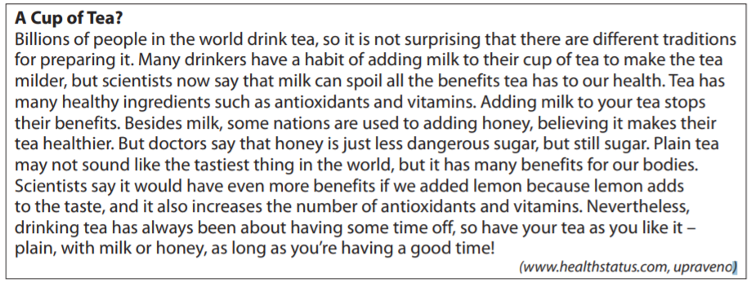
- According to the article, which tea is the healthiest to drink?
- tea with milk
- tea with lemon
- tea with honey
- tea with nothing

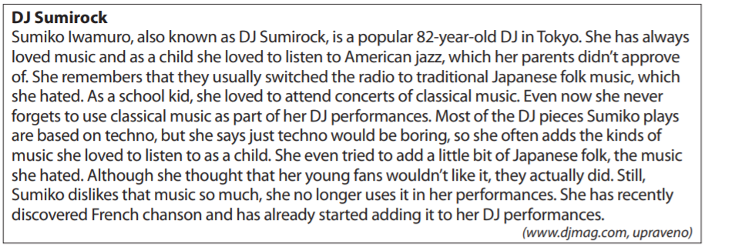
- What music does DJ SUmirock not use in her performance now?
- Japanese folk
- American jazz
- classical music
- French chanson

Co jsem se touto aktivitou naučil(a):
………………………………………………………………………………………………………………………………………………………………………………………………………………………………………………………………………………………………………………………………………………………………………

Autor: Lýdie Valešová
Toto dílo je licencováno pod licencí Creative Commons [CC BY-NC 4.0]. Licenční podmínky navštivte na adrese [https://creativecommons.org/choose/?lang=cs].

