Reading: Multiple Choice

Přečtěte si pět krátkých textů. Na základě informací v textech vyberte k úlohám 1-5 vždy jednu správnou odpověď A-D.
Dáme to! Reading: Multiple choice

________________________________________________________

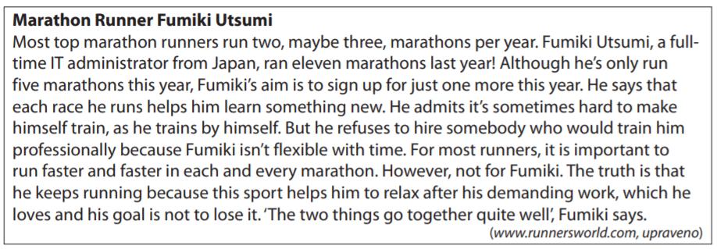
- What is Fumiki Utsumi’s plan?
- to improve his running time
- to work with a professional coach
- to keep his job as an IT administrator
- to run more marathons than last year

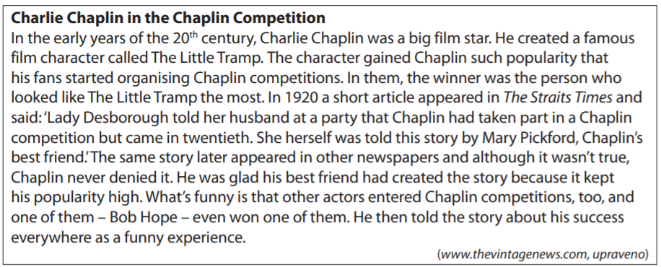
- Who invented the story about Charlie Chaplin taking part in a Chaplin competition?
- Bob Hope
- Marry Pickford
- Lady Desborough
- Charlie Chaplin himself

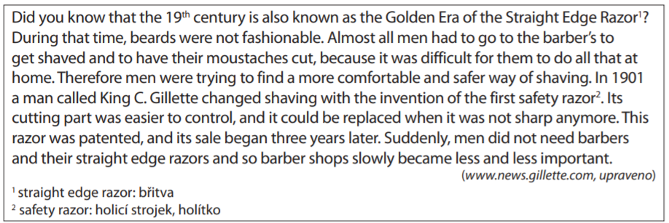
- What is the best title for this article?
- King C. Gillette’s Life
- Golden Era of Beards
- Development of Shaving
- Increasing Popularity of Barbers
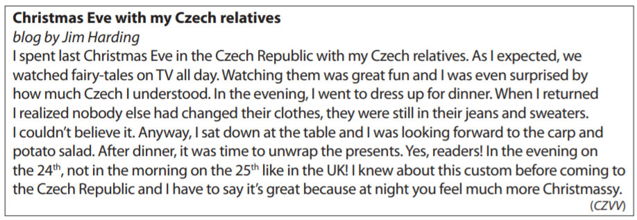
- What surprised Jim about the Christmas Eve he spent with his Czech relatives?
- the clothes worn for Christmas Eve dinner
- the films shown on TV at Christmas time
- the meals served on Christmas Eve
- the day set for opening gifts

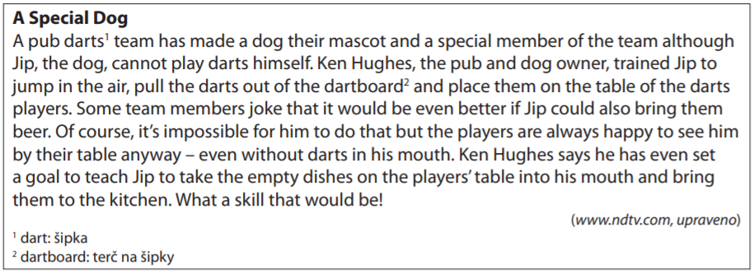
- What is Jip’s special skill?
- He brings drinks to the players.
- He takes darts¹ out of the dartboard².
- He throws darts¹ in his own special way.
- He removes plates from the players‘ table.

Co jsem se touto aktivitou naučil(a):
………………………………………………………………………………………………………………………………………………………………………………………………………………………………………………………………………………………………………………………………………………………………………

Autor: Lýdie Valešová
Toto dílo je licencováno pod licencí Creative Commons [CC BY-NC 4.0]. Licenční podmínky navštivte na adrese [https://creativecommons.org/choose/?lang=cs].

