Metodika a řešení: US Election

Tento pracovní list má žákům představit volební systém USA. Zároveň je seznámí se základními frázemi, které se pojí s volbami. Je vhodný pro žáky 2. stupně ZŠ a SŠ.
Anglická fráze „to hold an election“

________________________________________________________
- Connect pictures with names and historical milestones, political affairs or unique events.
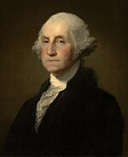 | 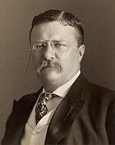 | 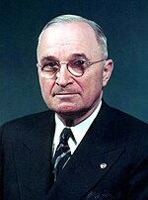 | 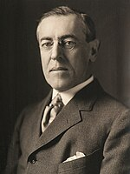
George Washington | Theodore Roosevelt | Harry S. Truman | Woodrow Wilson
Declaration of Independence | youngest person to become US president (aged 42) | authorized use of nuclear weapons in Nagasaki and Hiroshima | led the United States into World War I.
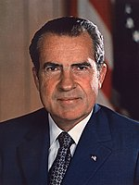 | 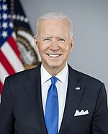 | 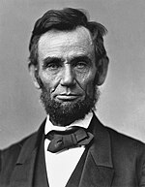 | 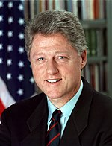
Richard Nixon | Joe Biden | Abraham Lincoln | Bill Clinton
Watergate scandal | dealt with the COVID-19 pandemic | Civil War, abolition of slavery | had an affair with intern Monica Lewinsky
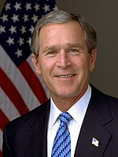 | 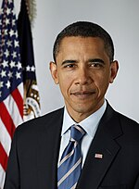 | 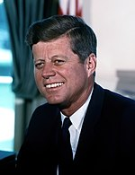 | 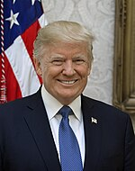
George W. Bush | Barack Obama | John F. Kennedy | Donald Trump
terrorist attacks on 9/11/2001, invasion of Afghanistan | first sitting US president to publicly support LGBT rights | assassinated in Dallas | the only US president to be impeached twice

Dejte žákům cca 5 minut, aby sami nebo ve dvojicích vyplnili tabulku. Následně společně zkontrolujte řešení a diskutujte: Co dalšího o prezidentech víte? Kdo z nich se zdá jako dobrý/špatný? Proč? Je možné být špatný prezident, ale dělat i dobré kroky? Dokážete dát příklad dobrého a špatného prezidenta ČR? Proč je tak vnímáte?
Zdroj: https://en.wikiedia.org/wiki/List_of_presidents_of_the_United_States
2. Translate the phrases. Watch the video and check.
TO HOLD AN ELECTION | ZORGANIZOVAT VOLBY, VOLIT
IN THE CONSTITUTION | V ÚSTAVĚ
AS LONG AS | DOKUD
FOR INSTANCE | NAPŘÍKLAD
PRESIDENT REMAINS IN POWER | PREZIDENT ZŮSTÁVÁ U MOCI, JE STÁLE PREZIDENTEM

3. Read the text and put the steps in correct order.
Vocabulary:

government = VLÁDA
election = VOLBY
nominee = KANDIDÁT
political party = POLITICKÁ STRANA
determine = URČOVAT
proportional = ODPOVÍDAJÍCÍ
cast a vote = DÁT HLAS
be inaugurated = BÝT INAUGUROVÁN, UVEDEN DO FUNKCE
endorse = PODPOROVAT
Ujistěte se, že žáci znají slovíčka uvedená výše a následně jim dejte 5–10 minut na přečtení textu na dalších stranách. Je vhodné následovat diskuzí o politických stranách USA – Znáte nějaké? Kdo jsou jejich zástupci v současných volbách? Kdo vyhrál poslední volby?

4. Look up information about one US president and describe his journey through the election process.
Tuto část je vhodné zadat jako domácí úkol, případně je možné ji využít k tvorbě prezentací a následnému mluvenému projevu v hodině.

STEP 3: GENERAL ELECTION  People in every state across the country vote for one President and Vice President. When Americans go to the polls in November they will select their favorite presidential candidate and their running mate.  When people cast their vote, they are actually voting for a group of people called electors. Except in the states of Maine and Nebraska, if a candidate receives the majority of the votes from the people of a state then the candidate will receive all electoral votes of that state.  The presidential nominee with the most electoral votes becomes the President of the United States. | STEP 4: ELECTORAL COLLEGE  The Electoral college is a process in which electors or representatives from each state in number proportional to the state’s population cast their vote and determine who will be president.  Each state gets a certain number of electors based on its representation in Congress. There are a total of 538 electors selected according to each state’s policy. Each elector casts one vote following the general election, and the candidate who gets more than half (270) wins.  The newly elected President and Vice President are inaugurated in January.
STEP 1: PRIMARIES AND CAUCUSES  There are many people who want to be President, each with their own ideas about how the government should work. People with similar ideas belong to the same political party. This is where primaries and caucuses come in. Candidates from each political party campaign through the country to win the favor of their party members.  Beginning in February the main voting events Primaries and Caucuses will lead to a selection of delegates who will represent the people at the upcoming conventions. The main focus will be on the results from Iowa, New Hampshire, Nevada and South Carolina, which can usually determine who the final presidential nominee for each party will be.  In a Caucus  Party members select the best candidate through a series of discussions and votes.  In a Primary  Party members vote for the best candidate that will represent them in the general election. | STEP 2: NATIONAL CONVENTIONS  Each party holds a national convention to select a final presidential nominee. State delegates from the primaries and caucuses selected to represent the people will now “endorse” their favorite candidates and the final presidential nominee from each party will be officially announced at the end of the conventions. The presidential candidate also chooses a running mate (Vice Presidential candidate). The presidential candidates campaign throughout the country to win the support of the general population.
Zdroj: https://kz.usembassy.gov/summary-of-the-u-s-presidential-election-process/#primaries-caucuses
 Autor: Šárka Hanetšlegerová
Toto dílo je licencováno pod licencí Creative Commons [CC BY-NC 4.0]. Licenční podmínky navštivte na adrese [https://creativecommons.org/choose/?lang=cs]

